**Task 1**

* Creating a python code to extract data from Mongodb in Ubuntu.

As the code need to be run and access Mongodb in Ubuntu, the oracle virtual machine was used to install Ubuntu OS.

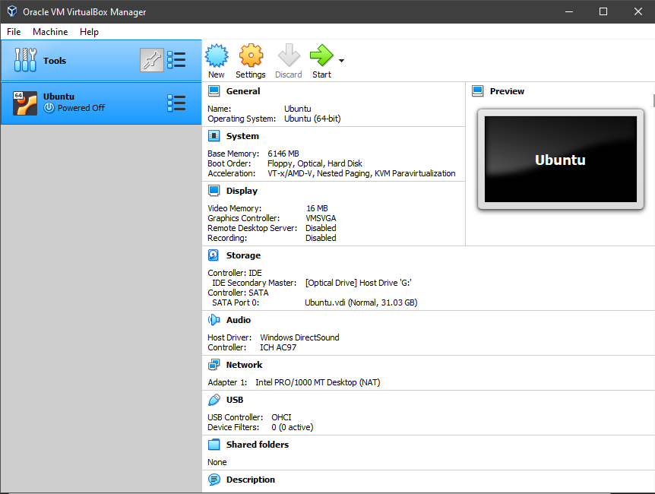

The Mongodb, Robo 3T, Python, PyCharm was successful installed in Ubuntu Virtual machine using terminal. The guidance can be obtained on the internet. It is easy to install in Ubuntu as its free platform.

The Mongodb require Robo 3t software to provide user interface. Figure below shows the Robo 3t interface on tibit_pon_controller database. The data (green frame) need to be fetch from database and sum up it by dates.

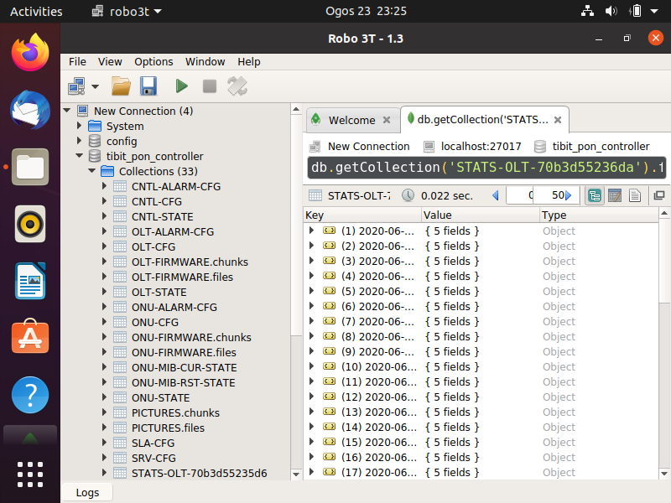

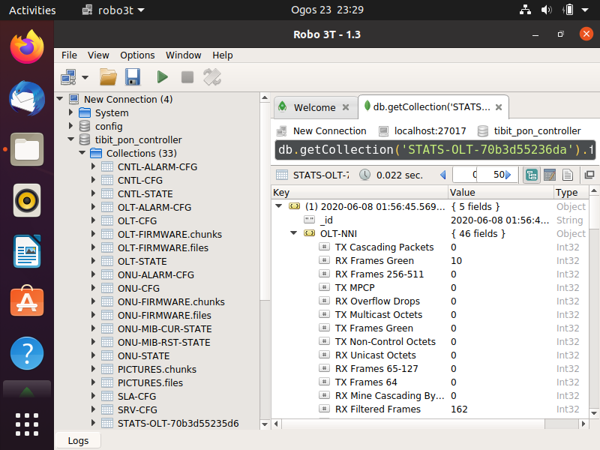

* The Python codes that have been developed can be get from this link -> <https://github.com/nevermoremir/Python_TMR-D>

The python code works by connecting to the database and specify to the targeted collection. The task given is to fetch green frame data from three collection which are ‘ Collection_STATS-OLT-70b3d55236da’ , ‘Collection_STATS-ONU-ALPHe3a69d67’, and ‘ Collection_STATS-ONU-ALPHe3a69d94’. Code work by fetch all the data on collection and sum up the green frame according to its dates. The sum up value is stored in array. Then the array will be inserted to data frame. Data frame will be converted to Excel. The results show in figure below.

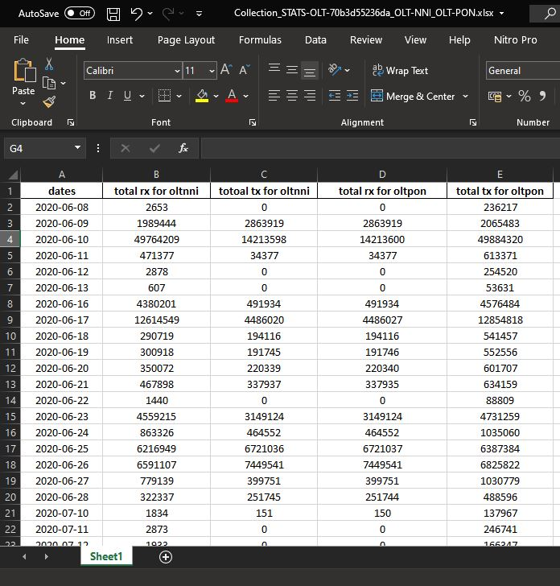

**Task 2**

* Setup the system testing of XG-Reach project using Spirent to pump the traffics.

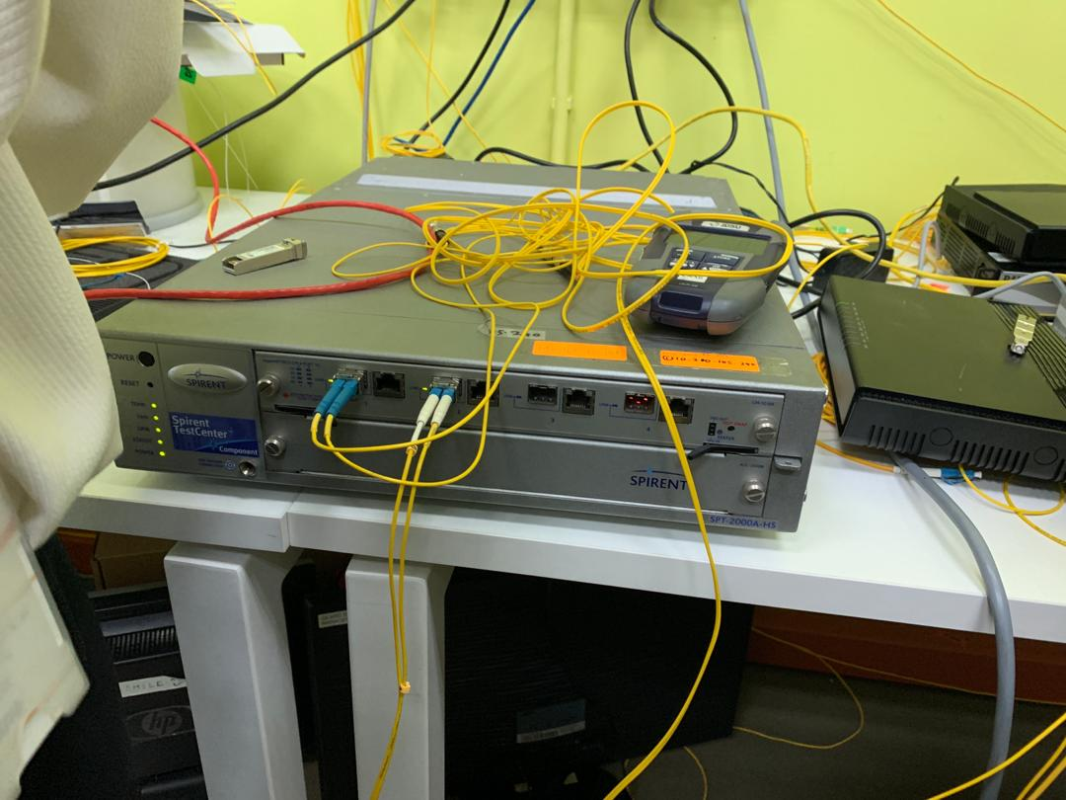

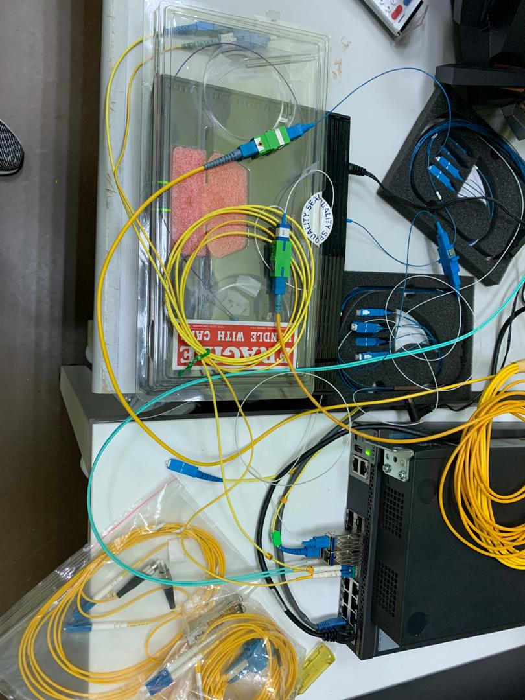Figure above is the direct setup from port 1 Spirent to Port 2 Spirent. This setup is for testing the Spirent performance. Using Spirent Test Center, each port has 1 device that will be pump the traffic with 1Gbps with tag VLAN ID 500 in bidirectional. The result was observed on Spirent Test Center software. The speed transmission is 1Gbps and no frame drop, or errors found. Therefore, the Spirent is working properly. Next setup is added the circulator between the transmission as figure below.

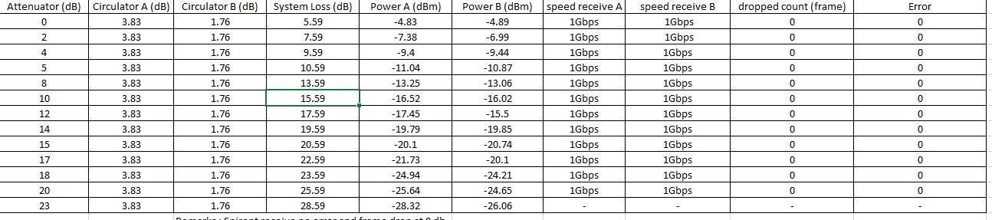 Circulator was used for achieving bi-directional transmission over a single fiber. The system was test with different attenuator to analyze the power loss, speed transmission and frame drop, or error. The testing result was shown in figure below.

The result conclude that the system has maximum speed, no dropped frame, and no error from 0db until 20db attenuator added. After 23db attenuator added, the frame cannot be captured because of the limitation of transceiver. The transceiver can only detect minimum power at -25dbm. Therefore, the system loses their functionality when lose is added up to 23db.

Then, the system setup added a new component which were ONU, OLT and splitter.

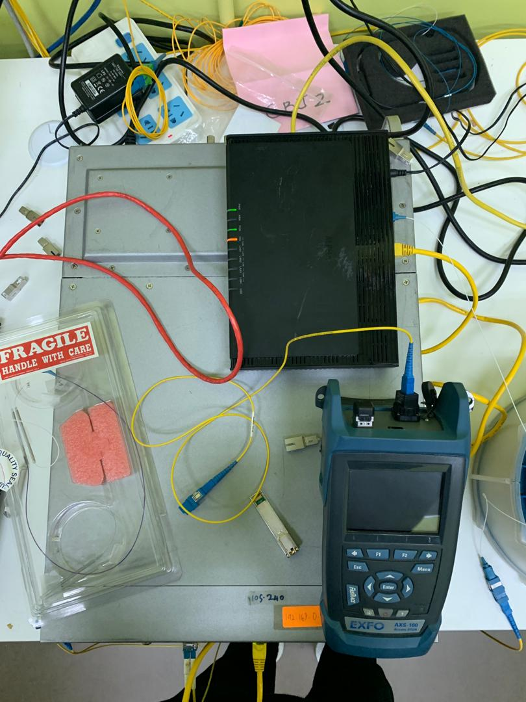

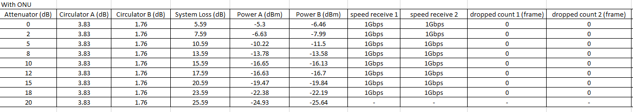The testing done same with previous setup. Different attenuator was used to analyze the performance of the system. The result was recorded in figure below.

The result concludes the system with ONU, OLT and splitter introduce more losses to the system. The system cannot detect the power laser when 20db attenuator is use.

To mimic the setup for XG-Reach projects, spool was added to the system to mimic the distance from CBJ2 to MMU. The spool use is 5km and 10km. Figure below is the example of spool used

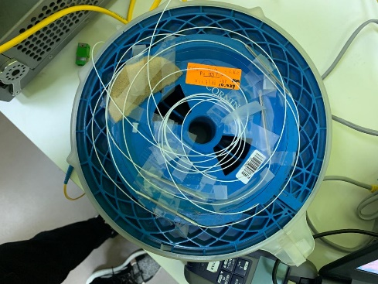

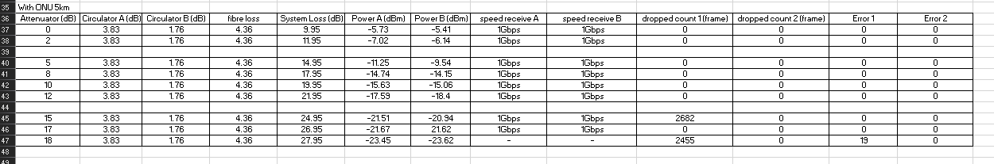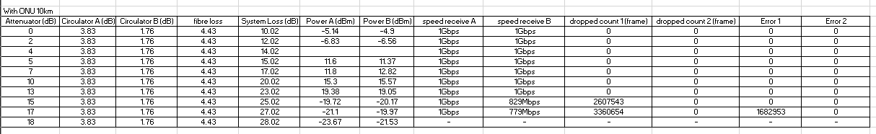

When the 5km spool was added, the system has more losses. The system can hold up until 17db attenuator before the system cannot detect the power laser. There were some losses at 15db attenuator. This is because the physical connection may be not tightened and loss some power and data. The data should be received with no losses at 15db.

When 10km spool was added, the system has more losses and error was found. The system speed transmission drops at 15db and proportional decrease toward the attenuator value. Some of frame dropped at 15db and 17db. At 18db, the system cannot detect the power laser anymore.